First upload, few changes made optimized imports, removing redundant if statements, Boolean and semi colons

-Inverted boolean in employee details to make more efficient less !

-Removed some redundant casts

-Simplified

String generatedfileName = fileName.toString(); return fileName.toString();

return generatedfileName;

Employee oldDetails = newDetails; newDetails.getEmployeeID()

-Removed as not needed newEmployee = employeeToAdd; employeeToAdd.getEmployeeID()

long currentRecordStart = byteToStart;

long oldByteStart = currentByteStart;

-Made variables and classes private and final where possible

-Deleted duplicated classes

-Dealt with empty catch blocks

-Explicit type argument String can be replaced with <>

- removed identical catch branches

-fixed redundant declarations

Removed redundant classes employee toString and JTextFieldLimit

merged search methods- merged searchbyemployeeId and searchbyemployeeSurname to search

Removed comments

Made method that can be called more efficiently when there’s an error also used in the add user dialog and with searches.

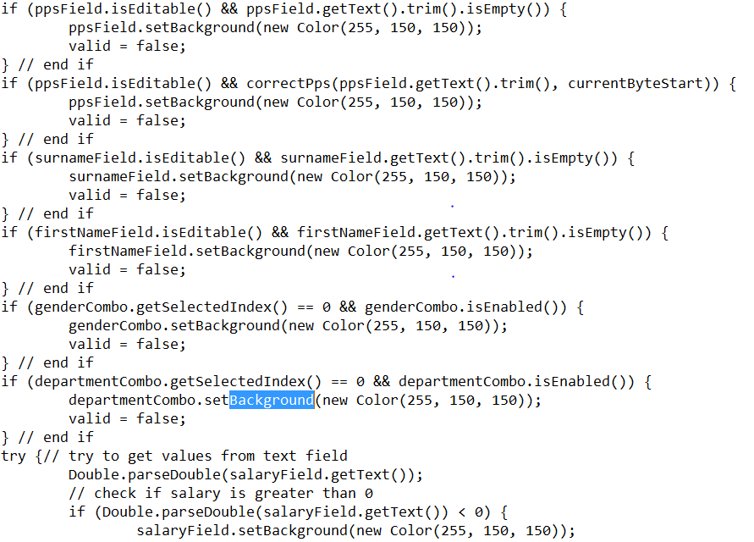

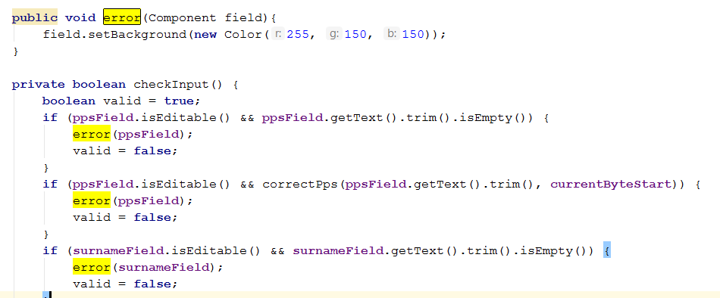

Merged The CloseWriteFile and closeReadFile into one CloseFile method

